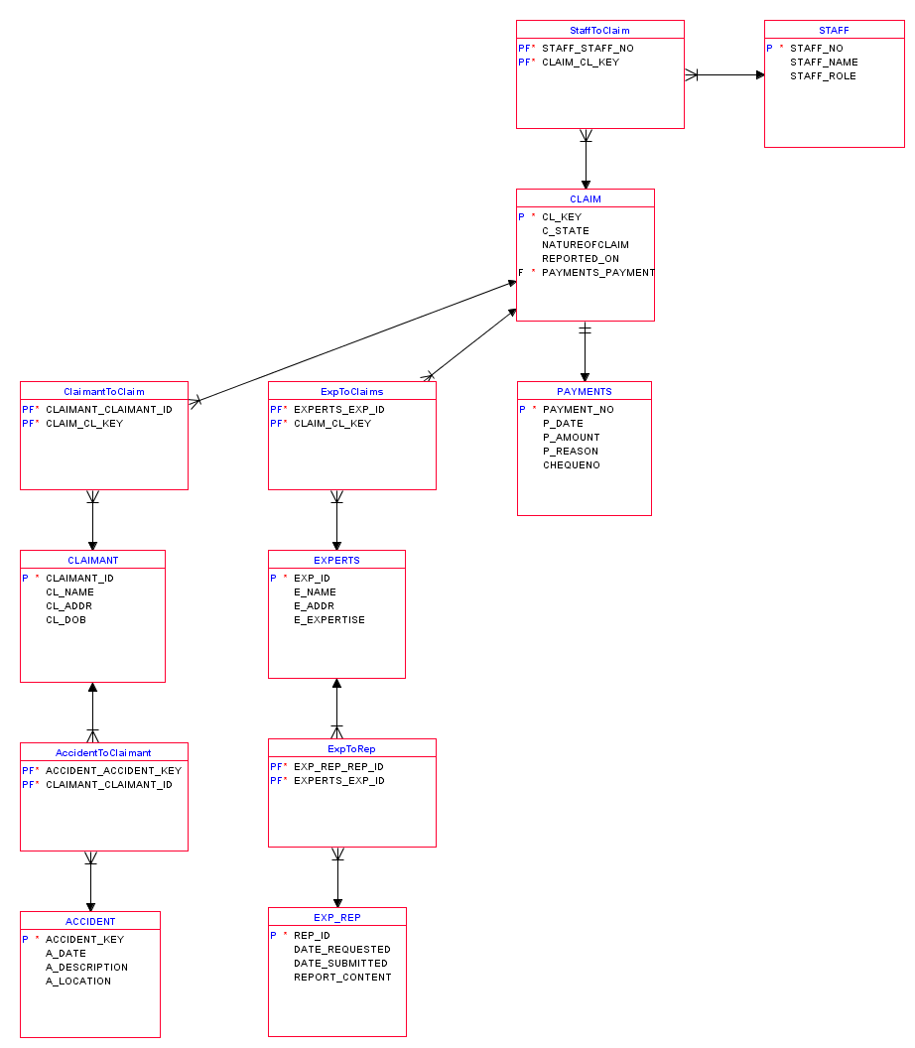

Claims:

Can only have one payment linked.

Can only be reported by one staff member.

Can have multiple experts who in turn bring with them expert reports.

Can only have one claimant who will in turn bring with them accident details.